SDG-Challenge

Final Report: Sustainable transportation in the healthcare system in Eindhoven

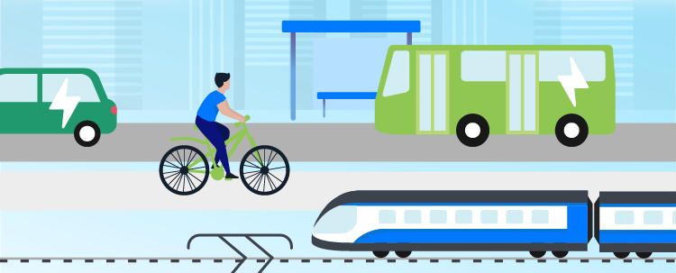

Student team: Alejandra Herrera Serrano, Alexandra Pintilie, Dimitris Chazakis, Emma Arregui Payeras, Ioanna Vasileiou, Machen Gao, Marta López Serrano

In collaboration with: Brainport Bereikbaar, Archipel, Vitalis

Date: 08-01-2025
Table of Contents:

1. Introduction 3
2. Background 4
2.1 Current situation 4
2.2 Trappers app 4
2.3 Other app initiatives 5
3. Our solution 7
3.1 Trappers app solution 7
3.1.1 Introduction to the app 7
3.1.2 Trappers solution explanation 7
3.1.3 Trappers reward mechanism 8
3.1.4 Distance categories 8
Distance Category 1: 0–5 km 8
Distance Category 2: 5-15 km 9
Distance Category 3: 15-30 km 9
Distance Category 4: 30+ km 10
3.2 Slogan campaign 11
3.2.1 Introduction to the slogan campaign 11
3.2.2 Behavioural change insights 11
3.2.2 Mental health benefits 13
3.2.3 Slogan explanation - marta and emma 14
4. Conclusion - add conclusion regarding slogans 15
5. References 15
Annex A: Reward system 17
Annex B: 19
References 21

Introduction
Improving commuting sustainability is central to the Netherlands' goal of reducing greenhouse gas emissions by 49% by 2030 (National Climate Agreement, 2019). Supporting this target, a 2024 mandate requires large employers to monitor and report work-related travel emissions (EuroDev, 2024). Thus, mobility in and around Eindhoven is becoming increasingly challenging. While this initiative has produced a lot of opportunities, the existing measures, such as parking management, bicycle facilities, and public transport reimbursements, have shown only a limited impact.
This finding aligns with structural factors such as comfort, long commuting distances, childcare responsibilities, and time constraints, which cannot be solved solely through awareness campaigns (Business.gov.nl, 2024; Rebecchi et al., 2020). Interviews with staff further confirm that convenience and comfort are the primary motivators for driving, while financial incentives are identified as the most significant motivators for behaviour change.
Therefore, the goal of this project is to enhance and systematise existing measures, making them more appealing, consistent, and effective. Based on staff feedback and behavioural evidence, financial incentives and gamified reward systems appear to be the most promising leverage points. According to the findings of previous experimental studies, the implementation of small but consistent monetary rewards has been shown to have a significant impact on the behavior of commuters, leading to a notable increase in cycling and a corresponding decrease in car use (Aldred et al., 2020; MDPI, 2020).
Based on this evidence, our further research will focus on finding and creating a more reasonable, fair and human-centred reward structure. The aim is to refine the incentive system into a more coherent and effective programme that can meaningfully support sustainable commuting among daytime healthcare staff.

Background

2.1 Current situation
This section outlines the current mobility situation experienced by healthcare workers within Archipel and Vitalis.
Healthcare workers tend to have a hectic and, hence, stressful daily life, which leads to decisions that prioritize the “getting the work done ” way of thinking rather than an approach that can serve multiple purposes as sustainability. The constant challenge of being on time and ready to serve the important cause of healthcare givers is the number one driver that pushes them to predominantly rely on private automobiles as their main mode of transportation. Cars carry the advantages of being comfortable, fast and reliable when someone has to travel for a longer distance. Coupling with the fact that a standard shift is between (07:00–17:00), a regional peak-traffic period, anyone can characterise them as the ideal means of transport for their case. Someone may propose public transport as an alternative, but this is viewed as slow and poorly matched to healthcare shift requirements. Flexibility is not offered in that case. The same can be said about cycling, which only works for the negligible distance of 5km, marking it as impractical. Last but not least, the awareness of existing sustainable mobility alternatives is low. All these have consequences both on the drivers’ and the environment’s end. The former, given the fact that they travel during peak hours, experience even more delays, which leads to stress. The latter is being polluted more due to elevated levels of CO₂ emissions, accustomed to the higher usage of automobiles.
Although the portrayal of the current situation is rather negative, healthcare workers are keen on behavioural change and transforming their lifestyle into a more sustainable one. To be exact, 80% of the employees indicate a willingness to be a part of mobility incentives. They show a strong interest in any financial remuneration or award being given by a “win per trip” system that incentivises sustainable choices. To also state some more encouraging percentages, 32% express interest in work-to-work carpooling and 51% would consider leasing a car if this choice was on the table. These insights reflect a workforce that is receptive to change, but a convincing campaign needs to be done.

2.2 Trappers app

Several measures have already been tried out to facilitate healthcare employee commuting and make mobility more sustainable in the city of Eindhoven. The Trappers app has been offered to healthcare workers to promote more sustainable commuting options (Trappers, 2025). The application is available for iOS and Android, requiring the employer’s intervention for the initial signup. It offers a cycling incentive scheme, aiming for a high impact. Its main function involves registering the bike rides of the users, using a GPS tracking system. Points are earned for the bike rides, which can be later redeemed to receive vouchers or other gifts at the Trappersshop. The awards include, but are not limited to, books, bike accessories, technological items, like laptops or tablets, and collaborations with big chains in the Netherlands, such as HEMA and bol.

Even though the reward system seems attractive and customer service has been reported to be friendly and helpful, the app faces certain limitations, according to the reviews found online in Google Play and the App Store, as well as in surveys conducted by Archipel. Apart from the privacy concerns caused by the continuous location tracking, the app has faced issues with missing trip registration and heavy settings draining the phone’s battery. The requirement for mobile data is another downside, faced by users who typically use only wifi. Additionally, Trappers can register only one work address, thus not rewarding employees who cycle between two or more work locations. Another one of the app’s limitations is the cycling-focused scheme it offers, meaning that other sustainable modes of transport, like walking, electric vehicles, or taking public transport, are not rewarded. This feature excludes potential users if they live a longer distance from their workplace, making it impossible for them to use a bicycle. On the other hand, individuals who live very close to the office often report feeling insufficient motivation to configure and use the app. The bike-centric nature of the application also excludes people with mobility issues or physical disabilities, preventing them from participating in the reward system. As Trappers is a mobile application, it is also inevitable to pose difficulties to certain employee groups, such as older generations who may be unfamiliar with modern technology, but would still be willing to transition to more sustainable modes of commuting.

2.3 Other app initiatives

To come up with solutions, inspiration can be drawn from initiatives in other cities or countries. Even though a city-specific context has to be considered for the final recommendation, it is useful to assess what other measures’ strengths, weaknesses and the reasons for their successful or unsuccessful adoption. As the Trappers application is the main focus, looking at similar reward system initiatives is the most beneficial for the assessment.

Pave Commute is an application available at Google Play and the App Store, aiming to encourage sustainable commuting for companies’ employees (Pave Commute, 2025). It is based on a reward system, where coins are used to receive prizes. It involves a social aspect through the interaction of users inside the app, and uses features such as car pooling. Pave Commute uses a tracking methodology that identifies the mode of transport used by the employee as well as the environmental impact of each trip. It offers a gamified way to engage entire teams to adopt sustainable mobility options. Its non-extensive adoption can be explained by the limited financial incentives provided to the users, not making the app seem attractive, and the constant location tracking, creating safety and privacy concerns.

Reiswijs is a similar Dutch gamified application, using rewards for sustainable commuting (Reiswijs, 2025). By choosing to cycle, take public transport, carpool, or work from home, users can automatically earn points to later receive rewards. Another feature of the app is the recommendation of alternative routes to take when roadworks are taking place in the user’s default route. The application tries to create a community of users, encouraging everyone to move more sustainably. To provide extra motivation, it allows participants to join challenges for extra rewards and fun (van Putten, 2025). It was developed in collaboration with Zuid-Holland Bereikbaar. Its weaknesses involve not enough rewards, excessive battery life usage, an unclear reward system, confusing some of its users, and unreliable tracking of the trips, thus making users not record all points earned.

Another app operating in the Netherlands is Fynch. Its functions are not limited to rewarding sustainable mobility alternatives (working from home, cycling, taking public transport, or using an electric car). It also provides a way to manage travel expenses and gives insights into carbon footprint (Fynch Mobility, 2025). Fynch is aiming at employees who want to concentrate their employees’ travel administration in one single platform. The app is integrated into each company’s HR system. Hence, reimbursements are directly added to the employees’ payroll. Fynch offers the possibility for either manual or automatic trip registration. This gives employees the freedom not to disclose GPS during every trip they make. The app’s critiques are mostly based on its frequent failures when it comes to automatic tracking. It has been reported that this mode is often inaccurate, thus obligating people to make corrections or use the manual mode. This defeats Fynch’s purpose, which is to save people time for tracking their own travels, as they claim that the app’s use will save 2 hours per employee per month. Another complaint concerns battery drainage, as with the applications previously mentioned.

Our solution
To encourage healthcare workers to shift from car-based commuting to more sustainable mobility choices, a dual approach that combines internal motivation and external motivation is proposed. This combination acknowledges that commuting behaviour is shaped by both habit and incentive, and that addressing only one of these dimensions is often insufficient to achieve lasting change.
The internal motivation solution focuses on awareness and emotional engagement through simple, relatable slogans. These slogans are designed to influence daily decision-making by associating cycling with comfort, relief, and well-being. The external motivation solution complements this by introducing a distance-based reward system that provides fair and tangible incentives for sustainable behaviour. By accounting for differences in commuting distance, this system ensures inclusivity and avoids disadvantaging employees whose mobility options are more limited.

3.1 Distance-based reward system via Trappers

3.1.1 Introduction to the app
As explained before, many employees in Eindhoven still rely on cars for their daily commute, even though the city offers excellent cycling and public transport infrastructure. To help the company make commuting more sustainable, our goal is not only to offer greener alternatives but to create a system that makes employees actually want to choose them.
The Archipel’s company already uses the Trappers app, which rewards sustainable mobility. However, our proposal focuses on improving and expanding this system to make it more accurate, engaging, and fair across different commuting distances.

3.1.2 Trappers solution explanation
We propose an improved version of the Trappers app where:
- Employees log in on the app when they leave home and log out upon arrival at work.
- The app detects or asks for their mode of transport (walking, bike, e-bike, PT, car, e-car).
- Based on the CO₂ reduction achieved by choosing a sustainable mode instead of their usual car commute, the employee earns points. As a reference point, an average newly registered car in the EU, Iceland, Norway, and the UK in 2019 emitted approximately 122.4 g CO₂/km (0.1224 kg CO₂/km), according to 2019 data from the European Environment Agency.
  - 1 kg of CO₂ reduced = 1 point.
- To keep the system fair, we divide employees into four categories, depending on the distance from their home to their workplace:
0–5 km, 5–15 km, 15–30 km, and 30+ km.
Longer commutes naturally allow for larger CO₂ reductions, so each distance category receives a different percentage multiplier, making the scoring proportional and realistic.
Distance multipliers:
- 0–5 km → 60% of the points
- 5–15 km → 75%
- 15–30 km → 90%
- 30+ km → 100%
These multipliers acknowledge that:
- It is easier for short-distance commuters to switch to biking,
- But long-distance commuters have more potential for CO₂ savings, so their point totals must be adjusted to remain fair.
Additionally, the system rewards consistent effort: using the app daily for a full week earns extra points, encouraging habit formation. This incentive is particularly motivating for users who live near the office and have previously indicated low motivation to configure the app.

3.1.3 Trappers reward mechanism
Points accumulated through sustainable commuting can be redeemed at the end of each month or quarter. Rewards can include:
- Gift cards (e.g, Amazon, Action, Restaurants, Supermarkets (AH Cadeaubon), etc)
- 50 points → €25 gift card
- 250 points → €30 gift card
- 500 points → €50 gift card
- 2,500 points → €100 gift card
- Vouchers for leisure activities (e.g, museums, cultural events, cinema, wellness (spa))
- Discounts or benefits offered through partner organisations
Users can choose when and how to redeem their points, whether they prefer to spend smaller amounts immediately or save up for higher-value rewards, allowing the system to adapt to different user preferences. See Annex A for a more detailed view on point distribution and corresponding rewards.

3.1.4 Distance categories

Distance Category 1: 0–5 km
Employees living within 0–5 km of the workplace generally walk, bike, or use the car.
For this distance, the most suitable sustainable options are:
- Walking (for employees already close enough)
- Regular bike
- E-bike
- Electric Car
These options are practical, quick, and require minimal effort due to the short travel time.
Switching from a short car commute (0–5 km) to walking, cycling, or e-biking results in a measurable CO₂ reduction, but to account that the total reduction is naturally smaller compared to longer distances, the 0.60 multiplier is applied.
- Points = CO₂ reduction × 0.60 (because this distance category receives 60% of calculated points)
The 60% multiplier ensures fairness within the system. Short-distance commuters can switch to sustainable modes more easily, but they also generate less CO₂ reduction due to the shorter trip length. The 60% adjustment keeps the points proportional, maintaining a balanced incentive structure across all distance categories.

Distance Category 2: 5-15 km
Employees living 5-15 km from the workplace typically choose between the regular bike, e-bike, public transport, car, or electric car. At this distance, switching from a conventional car to a more sustainable option results in a meaningful CO₂ reduction, as the commute is long enough to generate significant savings.
In this category, combining different transport modes starts to become common, for example, biking part of the way and then taking the bus, or driving to a parking area and completing the rest by bike. The system rewards the sustainable portion of these mixed-mode commutes to motivate employees to reduce car use as much as possible, even if they cannot eliminate it completely.
To ensure fairness across all distance ranges, this category receives a 75% multiplier.
- Points = CO₂ reduction × 0.75 (because this distance category earns 75% of the calculated points)
The 75% multiplier reflects that mid-distance commuters achieve more CO₂ savings than the 0–5 km group, while still having lower potential savings than longer-distance commuters.

Distance Category 3: 15-30 km
Workers commuting between 15-30 km go through different mobility challenges compared to shorter distances. At this distance, most employees rely on private cars because cycling becomes physically demanding, public transport often requires long transfers, and combining childcare or errands with the commute is common.
However, this distance category can offer a high potential for CO₂ reduction when shifting to more sustainable travel modes. Even small behavioural changes, such as replacing part of the route with public transport, lead to significant emissions savings due to the longer distance travelled.
For this group, fully switching to cycling is possible for a minority, but several realistic alternatives exist:
- E-bike or speed pedelec
Makes long-distance cycling feasible, especially for those with good routes or flexible schedules.
- Multimodal combinations
Examples:
  - Drive to a Park + Ride and finish by bus or bike
  - Bus/train + shared bike (OV-fiets or e-bike)
  - Car + sustainable last miles
- Electric car (EV)
For long-distance commuters who cannot shift modes, switching from petrol/diesel to EV provides a large CO₂ reduction that should also be rewarded.
Because longer distance commuters naturally produce much larger CO₂ reductions, they earn a higher proportion of the calculated points, using the 90% multiplier.
Points = CO₂ reduction × 0.90
(Employees in this category receive 90% of the points associated with their measured CO₂ savings.)
The 90% multiplier keeps the system balanced since commuters from distances 15 to 30km have a high potential for CO2 reduction and their trips are harder to change due to time, comfort and lifestyle constraints. Rewarding them at a higher multiplier seems fair to create motivation amongst the employees.

Distance Category 4: 30+ km
Employees with a significant commute (30+ km) usually opt for a car as a means of transportation, for the flexibility and reliability it offers. This group may prove highly resistant to change, as public transport alternatives may take longer and be found less reliable. However, this car-centric group has inherent difficulties caused by traffic, reduced parking availability, and additional expenses.

While it must be considered that not all employees have easily accessible public transport stations or time-efficient routes from their home to work, this group has a high potential for partial sustainable improvement. Particularly, in the case of visiting multiple patients or medical centres in the course of one day, rental bikes or public transport offer the workers more flexibility within the city. Thus, P+R initiatives may prove highly attractive to long-distance workers: while they utilize their car to arrive in Eindhoven, they park it for the day and make use of sustainable alternatives for in-city travelling. However, for this solution to be reliable and to build trust with the employees, a digital overview of the available parking spots, alongside the possibility to book ahead an e-bike/e-scooter for in-city mobility, is necessary; otherwise, the risk of arriving at a full parking lot, or a lack of ebikes, will reduce the credibility of the initiative.

To make sustainable mobility more attractive to long commute workers, it is important to support them as much as possible when choosing their route. The Dashboard of Brainport Bereikbaar has already compiled the addresses of the healthcare employees, as well as all existing public transport lines. If the location of partner shared mobility stations (e-bikes, e-scooters, rentals) could be added, and presented to the user via the app, this would minimise the mental load and facilitate transition and willingness to try. Another adjustment that could encourage the workers is to allow for adjusted working hours, with the purpose of ensuring that they can use better public transport connections, or travel outside the peak hours. These schedule adjustments do not have to be large to be significant; in some cases, a 20-minute forward could minimise waiting times by giving the worker access to different connections. These cases can be generalised based on starting location, final destination, and public transport timetables.

It is necessary to reflect on the awarded points that the impact workers make by choosing a sustainable mobility option. For workers who cover the majority of their long commute, the points gained will be 100% of the total possible points to be allocated. The goal is to recognise the effort and reward the desired behaviour; even though the worker may choose sustainable mobility only once a week, due to their long commute (30+ km), their CO₂ footprint is more significantly impacted.

3.2 Slogan campaign

3.2.1 Introduction to the slogan campaign
Even though the financial incentives of the app could be a valid solution for making people use bikes, combining them with internal motivation measures would increase the efficiency of the solution. To encourage a behavioural change in the health workers of Eindhoven, mostly the ones who live within a bikeable distance from their place of work, a poster campaign will take place to promote biking to work. The mental health benefits of biking will be the focus of the campaign named “Biking feels like…”, which pushes people to consider how they feel while biking. Examples are provided to reach different target groups.

3.2.2 Behavioural change insights
To gain insight into internal motivation and behavioural change principles, Rick Baggermans was contacted through Brainport Bereikbaar. His background in social psychology and his experience in rewards and punishment systems in behavioural change made a huge impact in our project. His insights helped us form our proposed solution and understand the problem deeper. Through this 1.5h session, we also managed to get insights into workers’ behaviour and response to certain initiatives, as well as the work performed previously in the Brainport region.
Rick highlighted that more than just an app is necessary in order to engage people and make them opt for more sustainable modes of transport for their work commute. According to the scientist, incentives (like the ones offered through Trappers) are, most of the time, not enough to cause a behavioural change. Moreover, incentives cannot increase infinitely as each company has a limited budget. Thus, the app has to be complemented by a different campaign.
Since we are focusing on people who live at a bikeable distance from their work, Rick encouraged us to show people the mental health benefits of biking. Even though people’s physical health also benefits from exercise, he said that people tend to respond more eagerly and openly to the mental health side of it. The mental benefits (e.g. reduced stress levels) are present from the first day of cycling, whereas the physical ones require more time. Hence, we created the campaign explained in the report, specifically targeting people who can bike to work. In the Brainport region, around 60% of people live between 0-15 kms away from work. This consists of the perfect target group for our project, as there is a lot of potential in this group of people. Also, people who currently choose the car have the possibility to switch to biking, but they are simply “stuck” in their heads and their habits, according to the scientist’s research. To make them choose a different way to go to work, we need to disrupt this thinking pattern.
Thanks to Rick’s suggestion, we avoided pinpointing the negative sides of using the car to commute. By highlighting the downsides, people are potentially reluctant to believe what is presented to them. They might feel attacked or create a defensive approach towards the respective campaign. As a result, our campaign is specifically focused on the positive aspect of biking, and we do not mention the negative side of the car, which includes heightened stress levels and damage to the environment.
Furthermore, even though sustainability is an incentive to adopt alternative modes of commute than the car, sustainability alone is not enough to cause a change in behaviour, according to the specialist. When sustainability is at stake, people tend to put comfort and speed above everything. A more internal change is required to actually make people break their pattern and change habits. Consequently, our campaign is not focused on the sustainability aspect of biking.
Another insight gained from the session with the behavioural scientist is the need for a “simple” solution. He presented us with different examples of previous initiatives trying to encourage workers to use sustainable transport to work, such as emails from management, spray paint on the bike lanes, and posters. The simple initiatives require significantly less effort, time, and resources. According to the scientist, such initiatives are more worth it than going for a complicated campaign that might not render the expected results in the end. It has been proven during their previous work at Brainport Bereikbaar that simplicity can actually motivate people enough to see a change in behaviour. That is why our campaign might look simple from an outside perspective, but it is based on science and the insights gained through our research on workers’ behaviour. Our goal is to make our message “Biking feels like…” linger in the subconscious of the workers in order to motivate them to take the bike.

3.2.2 Mental health benefits
Thus, based on psychology scientist interviews and literature reviews, while financial incentives (such as the proposed reward system) provide a necessary baseline, it is insufficient for health workers to disrupt deep-rooted commuting habits. Habitual travel choices are often automatic and cognitively “locked in,” meaning that increasing monetary rewards alone rarely leads to sustained behaviour change (Claudy & Peterson, 2014). To ensure the success of the new reward system, our strategy is therefore grounded in a psychological understanding of commuting as a behavioural and transitional space.

Based on previous meetings, the healthcare workers at Archipel are facing particularly high levels of occupational pressure, with stress-related absenteeism rising by 36% in recent years. For these employees, the commute is not merely travel time; it functions as a psychological transition between a demanding work environment and home life, shaping daily stress levels and overall well-being.
Current driving habits can further exacerbate this stress. Wild and Woodward (2019) argue that car commuting is often characterised by high levels of unpredictability and prolonged periods of “dead time”, leading to feelings of learned helplessness during traffic congestion. In contrast, they find that cyclists report higher levels of subjective well-being, which can be explained through two key psychological mechanisms:
First, sensory stimulation through outdoor exposure helps disrupt rumination, which refers to repetitive and stress-inducing thought patterns, thereby creating a “clear mind” effect (Wild & Woodward, 2019). Second, cycling offers a strong sense of autonomy and arrival-time reliability: unlike car drivers stuck in traffic, cyclists retain control over their speed and route, restoring feelings of self-efficacy and predictability (Wild & Woodward, 2019).
A key insight from our consultation with behavioural scientists is the distinction between “reasons for” and “reasons against” behaviour change. Claudy and Peterson (2014) note that perceived barriers such as effort, inconvenience, or discomfort often outweigh incentives, particularly when habits are deeply entrenched. In this context, the temporal dimension of rewards becomes critical.
Physical health benefits (e.g. weight loss or compliance with WHO activity guidelines) represent delayed gratification, as they typically require weeks or months to materialise (WHO, 2010). In contrast, mental health benefits are experienced immediately. Feelings of stress reduction and mental clarity can occur on the very first active commute. By foregrounding this instant psychological reward, the intervention directly addresses the inertia of habitual car use and lowers the cognitive threshold for behavioural experimentation (Claudy & Peterson, 2014; Wild & Woodward, 2019).
Even when mental health benefits are recognised, physical and practical barriers can still inhibit behavioural change. A systematic review by Schäfer et al. highlights that many commuters avoid cycling because they wish to avoid sweating or arriving at work physically exhausted (Schäfer et al., 2020; Neumeier et al., 2017). This insight directly supports the inclusion of e-bikes as a core component of the intervention, particularly for medium-distance commutes (15–30 km).
E-bikes reduce perceived effort while preserving exposure to the outdoor environment, enabling employees to access the mental benefits of active commuting without the physical cost of exertion (Frank et al.). In this sense, they operate as a low-threshold entry point into sustainable mobility. This is particularly relevant in the Archipel context, where approximately 90% of employees live within 12.5 km of their workplace, making cycling a feasible alternative for the majority of staff, whether assisted or unassisted.
While employees may initially be motivated by immediate mental relief, the long-term benefits of active commuting accrue at the organisational level. The World Health Organization (WHO) recommends a minimum of 150 minutes of moderate physical activity per week, a threshold that can be met through a daily active commute of approximately 15 minutes each way (Johansson et al.). Over time, this contributes to improved physical health outcomes and reduced absenteeism.
Importantly, Schäfer et al. identify the employer as the most influential actor in enabling and normalising active commuting. Interventions are significantly more effective when supported by managerial endorsement and visible role modelling. This provides the scientific basis for the proposed communication and leadership toolkit, which equips team leaders to frame sustainable commuting as a legitimate and professional strategy for reducing stress, preventing burnout, and improving overall workforce resilience rather than as a purely individual lifestyle choice.

3.2.3 Slogan explanation
The slogan campaign “Riding a bike feels like…” is designed as a simple behavioural nudge that lowers the mental barrier to choosing the bicycle. Instead of instructing employees or emphasising sustainability goals, the campaign reframes cycling as an emotionally rewarding and familiar experience.
Each slogan completes the sentence “Riding a bike feels like…” with a short, recognisable moment of comfort, relief, or enjoyment. Examples include:
- “…that first coffee in the morning.”
- “…a reset button between shifts.”
- “…sitting down after standing all day.”
- “…stretching your back when it finally cracks.”
- “…silence after a noisy day.”
- “…doing something kind for your body.”
- “…being a kid again, even if only for a moment.”
- “…catching a streak of green lights.”
- “…clean sheets after a shower.”
- “…finishing a shift and stepping outside into daylight.”
By evoking positive emotions and everyday pleasures, the slogans work through affective priming, linking cycling to immediate mental rewards rather than delayed benefits. This is particularly relevant for healthcare workers, whose commuting decisions are often habitual and made under time pressure.
The slogans are kept short and repetitive so they can linger subconsciously and subtly disrupt automatic car use habits. These posters can be displayed in high visibility locations such as entrances, break rooms, and bike parking areas, so that they require no active engagement and add minimal cognitive load.
At the bottom of each poster, the following line is included:
“Use Trappers to unlock those feelings and more!”
This line, accompanied by a QR code, provides a low-threshold link to the existing reward system without making the app the central focus of the campaign. The slogan first creates openness and internal motivation; the app then offers a practical way to act on that motivation.

Conclusion
This project addressed the challenge of making healthcare commuting in Eindhoven more sustainable, acknowledging that existing mobility measures have had limited impact due to deeply ingrained car-use habits.
Based on healthcare workers’ insights and behavioural research, the study demonstrates that combining financial incentives with intrinsic motivation is more effective in influencing commuting behaviour than applying either approach alone. The enhanced Trappers reward system provides a fair and inclusive external incentive by accounting for CO₂ reduction, commuting distance, and transport mode, ensuring proportional rewards for employees with diverse mobility constraints.
Complementing this, the slogan campaign “Riding a bike feels like…” addresses the psychological aspects of commuting by lowering mental barriers and highlighting immediate mental health benefits such as stress reduction and well-being. By connecting emotionally positive slogans to the Trappers app, the campaign converts internal motivation into practical engagement with the reward system.
Together, these interventions form a complementary system in which intrinsic motivation encourages initial behavioural change, while external incentives support consistency and habit formation. By implementing this strategy, Archipel and Vitalis can foster a workforce that is not only greener and more sustainable, contributing to Eindhoven’s climate goals, but also mentally healthier and more resilient.

References

Annex A: Reward system
In order to both achieve an increase in the amount of workers who use sustainable mobility practices while also creating systems that reward long term behaviour, the rewards can be split in 4 tiers, with an additional bonus incentives option. The tiers reflect point amounts with immediate gratification and long term, definitive sustainable behaviour improvement.

Table 1: tier 1 “Quick wins” (immediate gratification)

Points required | Possible Rewards | Reasoning
5 | Coffee voucher (approx €5). | Quickly achievable for most commuters, low stakes, builds habit.
5-10 | Supermarket voucher (€10- €15). | Generally helpful reward, needing a certain degree of dedication to obtain.
10-15 | Cinema vouchers; bike accessories. | Entertainment purpose;  Further supporting the commuters.

Table 2: tier 2 “Monthly achievements” (medium term goals)
Points required | Possible rewards | Reasoning
15-20 | €20 - €25 gift card (Bol, Action, Amazon etc). | Achievable within 3-4weeks of consistent sustainable commuting.
20-30 | Restaurant voucher (€30-€40). | Quality of life, a social focused reward.
30-45 | Wellness voucher (spa, sauna entry, massage); Rituals gift package. | Premium relaxation, addresses stress.

Table 3: tier 3 “Quarterly milestones”
Points required | Possible rewards | Reasoning
50-60 | €50 gift card; annual museum pass. | Proportional to long term consistent effort; culturally focused.
75 - 100 | €75-100 voucher for theme parks. | Family orientated; enticing for parents.
100-150 | Tech gadget (eg. noise cancelling headphones). | High value practical item.

Table 4: tier 4 “Longterm champions” (quarterly/annual)
Points required | Possible rewards | Reasoning
200-250 | €150-200 voucher (supermarket, travel, relaxation). | Proportional to months of commitment to sustainable transport and lifestyle changes.
+500 | €350+ annual reward (ebike, premium expense, possibility to receive bonus day off). | Recognition and reward for year-long sustainable behaviour.

Table 5: Bonus incentives:
Achievement | Bonus points | Reasoning
New sustainable mode unlocked | +5 points | Encourages exploration; enticing to new users.
5 days streak sustainable commute | +20 points | Weekly consistency bonus
20 days streak | +50 points | Monthly consistency bonus

Annex B:
Poster template:
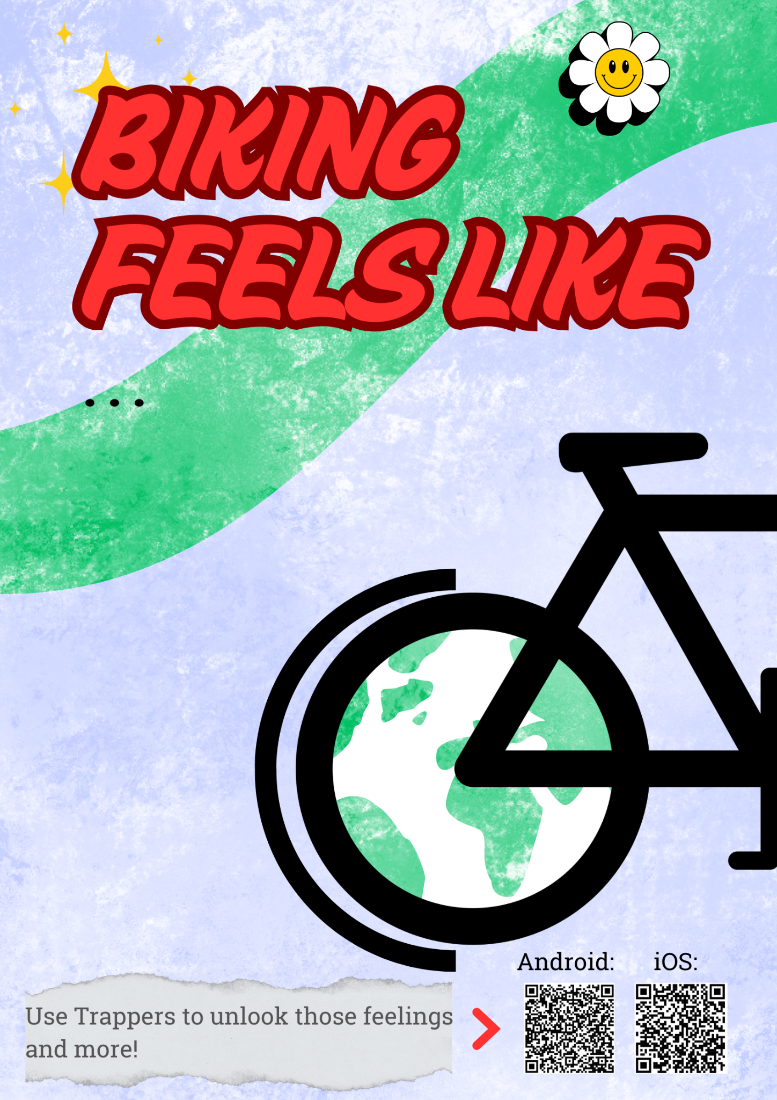
Poster example:
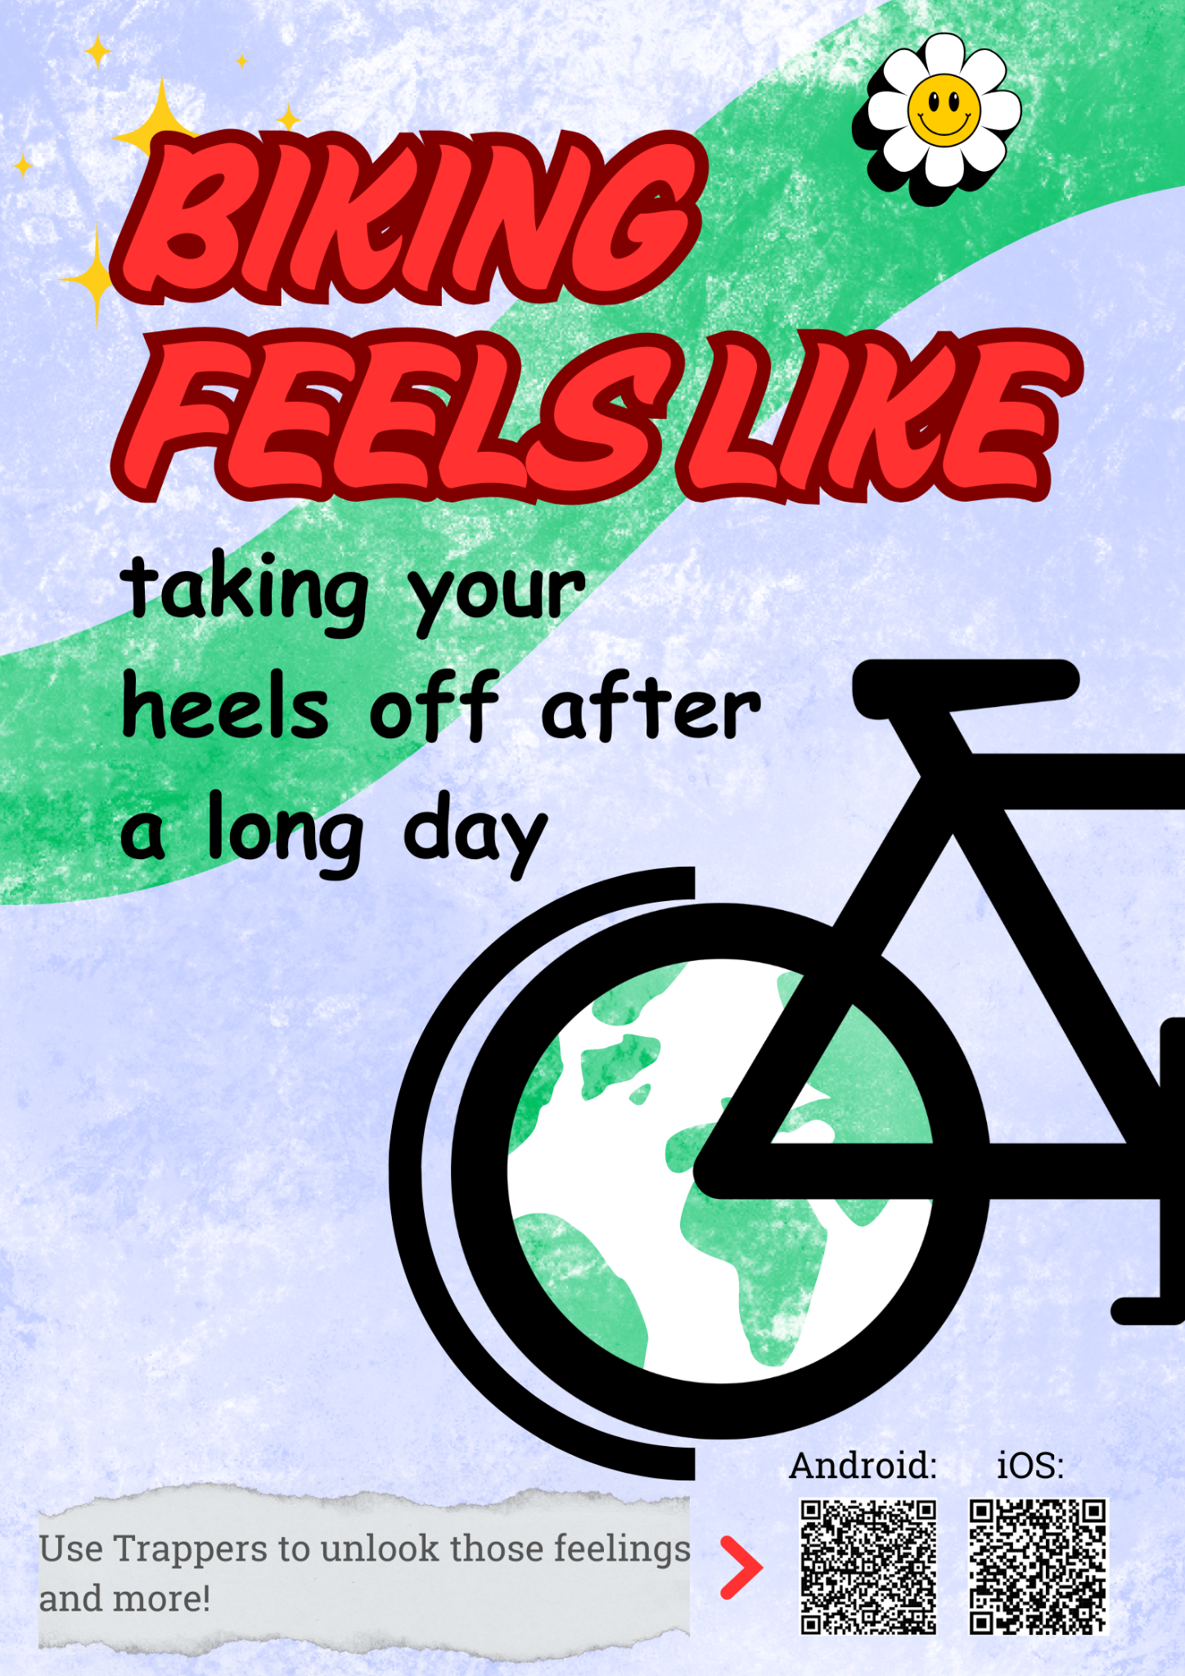

References
Aldred, R., Woodcock, J., & Goodman, A. (2020). Incentivising commuter cycling: Behavioural responses to financial and non-financial rewards. Journal of Transport & Health, *18*, 100901. https://doi.org/10.1016/j.jth.2020.100901
Business.gov.nl. (2024). Travel allowance and mobility reimbursements for employees. Retrieved from https://business.gov.nl/regulation/travel-allowance/
Claudy, M. C., & Peterson, M. (2014). Understanding the Underutilization of Urban Bicycle Commuting: A Behavioral Reasoning Perspective. Journal of Public Policy & Marketing, 33(2), 173–187. https://doi.org/10.1509/jppm.13.087EuroDev. (2024). Employee benefits and compensation to meet Dutch commuting regulations. Retrieved from https://www.eurodev.com/blog/employee-benefits-and-compensation-to-meet-dutch-commuting-regulations
European Environment Agency. (2020, June 26). Average CO₂ emissions from new cars and new vans increased again in 2019. https://www.eea.europa.eu/highlights/average-co2-emissions-from-new-cars-vans-2019
Fynch Mobility. (2025). Het HR platform voor mobiliteit en declaraties. https://fynchmobility.com/
Henriques-Neto, D., Peralta, M., Garradas, S., Pelegrini, A., Pinto, A. A., Sánchez-Miguel, P. A., Marques, A., Henriques-Neto, D., Peralta, M., Garradas, S., Pelegrini, A., Pinto, A. A., Sánchez-Miguel, P. A., & Marques, A. (2020). Active Commuting and Physical Fitness: A Systematic Review. International Journal of Environmental Research and Public Health, 17(8). https://doi.org/10.3390/ijerph17082721
MDPI. (2020). The impact of gamified mobile applications on sustainable travel behavior: A case study. Retrieved from https://www.mdpi.com/2071-1050/12/18/7678
National Climate Agreement. (2019). National Climate Agreement The Netherlands. Rijksdienst voor Ondernemend Nederland. Retrieved from https://english.rvo.nl/sites/default/files/2020/07/National%20Climate%20Agreement%20The%20Netherlands%20-%20English.pdf
Pave Commute. (2025). How to works! https://pavecommute.app/features/
Raustorp, J., & Koglin, T. (2019). The potential for active commuting by bicycle and its possible effects on public health. Journal of Transport & Health, 13, 72–77. https://doi.org/10.1016/j.jth.2019.03.012
ReisWijs. (2025) Vind de beste manier voor je gaat. https://www.reiswijs.nu/
Rebecchi, A., Capolongo, S., & D’Alessandro, D. (2020). Work-related determinants of commuting mode choice in the Netherlands: A systematic review. International Journal of Environmental Research and Public Health, *17*(15), 5405. https://doi.org/10.3390/ijerph17155405
Schäfer, C., Mayr, B., Fernandez La Puente de Battre, M. D., Reich, B., Schmied, C., Loidl, M., Niederseer, D., & Niebauer, J. (2020). Health effects of active commuting to work: The available evidence before GISMO. Scandinavian Journal of Medicine & Science in Sports, 30(S1), 8–14. https://doi.org/10.1111/sms.13685
Trappers. (2025). Veelgestelde vragen. Ontdek hier alle antwoorden op je vragen. NFP Groep. https://site.trappers.net/klantenservice-faq/trappers-app#/
Universiteiten van Nederland. (2025). *Collective Labour Agreement of Dutch Universities 2025-2026*. Retrieved from https://www.universiteitenvannederland.nl/en/cao.html
van Putten. (2025, November 3). Travel smarter: earn rewards with new ReisWijs app. RotterdamStyle. https://rotterdamstyle.com/public-transportation/travel-smarter-earn-rewards-with-new-reiswijs-app
Wild, K., & Woodward, A. (2019). Why are cyclists the happiest commuters? Health, pleasure and the e-bike. Journal of Transport & Health, 14, 100569. https://doi.org/10.1016/j.jth.2019.05.008
Wojan, T. R., & Hamrick, K. S. (2015). Can Walking or Biking to Work Really Make a Difference? Compact Development, Observed Commuter Choice and Body Mass Index. PLOS ONE, 10(7), e0130903. https://doi.org/10.1371/journal.pone.0130903
World Health Organization. (2010). Global recommendations on physical activity for health. World Health Organization. https://iris.who.int/handle/10665/44399

